# High Level Requirements and Objectives of Students

In order to get an idea what the students are really looking for in a job brokerage platform, a survey will be conducted. The prerequisites for this survey are the mock-ups of the platform as a website or an app. These mock-ups provide the discussion basis for the students.

## Define the objective

The objective of this questionnaire is to gather information on what the students are really looking for on a job brokerage platform. Furthermore, it should be tested if the students are pleased with the sign-up process of the platform and if the navigation is intuitive.

* Clear requirements from the student for the platform and its convenience
* Feedback and suggestions for add-ons for the platform interface
* Relevance for them in the job searching process

## Define the target survey group

The target group for the questionnaire are all students of the FHNW.

## Select the sample group

The sample group of the questionnaire are the students of the Agile Business Analysis class. The class will be divided into 4 groups. Each group has a supervisor which is represented by one of the project team member. In each group one student will be using the paper-computer.

Every page of the mock-up has to be printed out and the supervisor guides the user through the website.

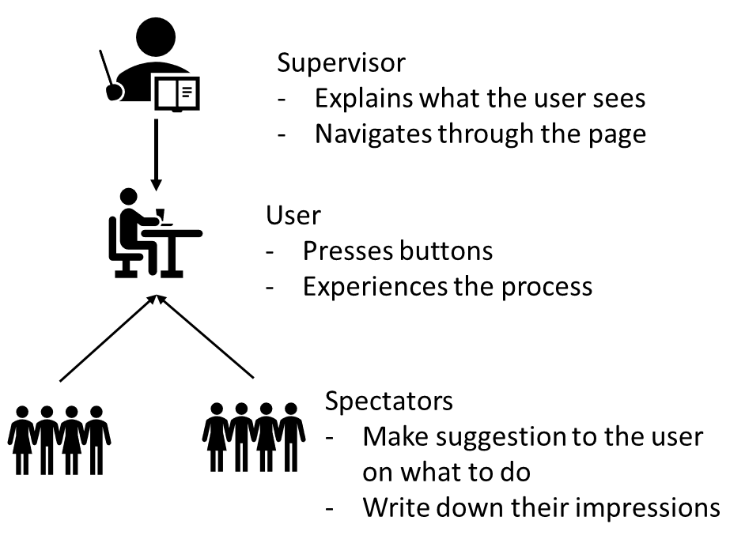

## Select the distribution and collection methods

The questionnaire will be distributed in class via an online tool. The demo-website will be demonstrated on the projector.

## Survey questions

|  |  |
| --- | --- |
| No. | Question |
| 1 | How would you describe the value proposition of the platform? |
| 2 | What core services and functions would you want the platform to do? |
| 3 | How do you currently search for new jobs? |
| 4 | How often are you looking for new jobs or opportunities? |
| 5 | What is the most tedious task for you in the job finding process? |
| 6 | Do you already know in which industry sector you want to go? |
| 7 | Do you know exactly what kind of work you would like to do? |
| 8 | Do you know exactly what kind of work you **don't** want to do? |
| 9 | Would you be willing to give access to your Transcript of Records, if it would increase your career-chances? |
| 10 | Which function have you been missing the most in existing job platforms up to now? |

|  |  |
| --- | --- |
| No. | Justification for the question |
| 1 | Is it clear for the user what is better on this platform then on others? Does the user know what to do on it? |
| 2 | If he understands the VP of the platform, what would he do different to make it better in order to assist his needs. |
| 3 | Give the percentage of students who are looking for a Job online. |
| 4 | How often would our platform come into use when it is working. |
| 5 | Can this task be solved by our platform? |
| 6 | Is the career path clear for the student or is he dependent on a suggestion? |
| 7 | Is the career path clear for the student or is he dependent on a suggestion? |
| 8 | Is the career path clear for the student or is he dependent on a suggestion? |
| 9 | Can we use his data? |
| 10 | If he understands the VP of the platform, what would he do different to make it better in order to assist his needs. |

## Testing the Survey questions

Not yet tested!